Code: Flex Balls 2
Send Feedback

Remember the balls that are being exported. We want to stack and fit balls in the box like this -
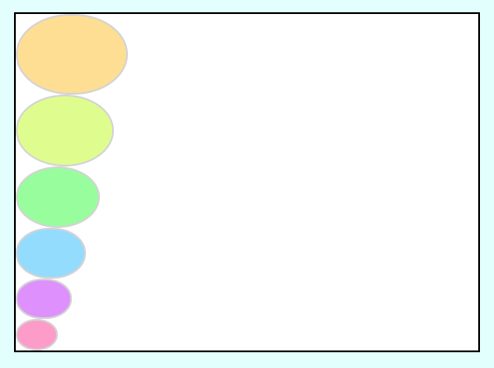

But there has been a problem with the box, it has shrunk all of a sudden ! So we cannot fit all balls in one line, thus let's move 2 balls from the top and put them aside like this -
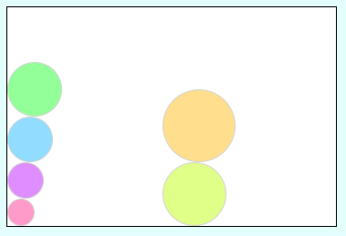

Now, the box is put on the truck to be exported. But it got rotated by 180deg while loading and the box content now looks like this. So make relevant changes to code to get this arrangement -
